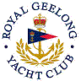 | Royal Geelong Yacht Club Inc.  Est 1859
Trophy Deed of Gift.

Trophy: | Cruising Division Aggregate Bowl
Presented by:
Date:
For: | Cruising Division Aggregate
Remarks / Revisions
Click here to View Recipients

